

**CAPSTONE PROJECT REPORT**

**Report 2 – System Requirement Specification**

– Thu Duc, October 2022 –

**Table of Contents**

I. Project Report **5**

1. Status Report 5

2. Team Involvements 5

3. Issues/Suggestions 5

II. System Requirement Specification **6**

1. Overall Description 6

1.1 Product Overview 6

1.2 Business Rules 6

2. User Requirements 8

2.1 Overview 8

a. Use Case Diagram 8

b. System Actors 8

c. Use Cases List 9

2.2 Authentication 11

a. Login. 11

b. Logout 13

2.3 Manage Profile 14

a. Get personal profile. 14

b. Edit profile 15

2.4 Manage Project 17

a. Get Project List 17

b. Create Project 18

c. Update Project 20

d. Delete Project 21

2.5 Manage Member 23

a. Get Member List 23

b. Add Member 24

c. Edit Member 26

d. Remove Member 28

2.6 Manage Group 29

a. Add Group 29

b. Edit Group 30

c. Delete Group 31

2.7 Manage Test Case 31

a. Get List Test Case 31

b. Add Test Case 32

c. Edit a Test Case 34

d. Delete Test Case 36

2.8 Manage Milestone 37

a. Get List Milestone 37

b. Add Milestone 38

c. Edit a Test Case 40

d. Delete Test Case 42

2.9 Manage Test Plan 43

a. Get List Test Case 43

b. Add Test Case 44

c. Edit a Test Case 46

d. Delete Test Case 48

2.11 Manage Report 49

a. Add Report 49

2.13 Manage Settings 49

3. Functional Requirements 49

3.1 System Functional Overview 49

a. Screen Flow 49

b. Screen Details 49

c. Screen Authorization 50

d. Non-Screen Functions 50

e. Entity Relationship Diagram 50

3.2 <<Feature Name 1>> 51

a. <<Function Name 1>> 51

b. <<Function Name 2>> 52

3.3 <<Feature Name 2>> 52

4. Non-Functional Requirements 53

4.1 External Interfaces 53

a. User Interfaces 53

b. Software Interfaces 53

c. Hardware Interfaces 54

d. Communications Interfaces 54

4.2 Quality Attributes 54

a. Usability 54

b. Reliability 54

c. Performance 55

d. Dependability 55

d1. Security 55

d2. Safety 55

e. Supportability 55

f. Design Constraints 55

g. Support Documents 55

h. Purchased Components 56

5. Other Requirements 56

5.1 Appendix1 - Messages List 56

5.2 Appendix2 - … 56

# I. Project Report

## 1. Status Report

| **#** | **Work Item** | **Status** | **Notes (Work Item in Details)** |
| --- | --- | --- | --- |
| 1 |  | Pending |  |
| 2 |  | In Progress |  |
| 3 |  | Completed |  |

## 2. Team Involvements

| **#** | **Task** | **Member** | **Notes (Task Details, etc.)** |
| --- | --- | --- | --- |
| 1 |  | DuyHL |  |
| 2 |  | TuNT |  |
| 3 |  | KhoaNT |  |
|  |  | BaoDT |  |

## 3. Issues/Suggestions

| **#** | **Issue** | **Status** | **Notes (Solution, Suggestion, etc.)** |
| --- | --- | --- | --- |
| 1 |  | Pending |  |
| 2 |  | In Progress |  |
| 3 |  | Completed |  |

# II. System Requirement Specification

## 1. Overall Description

### 1.1 Product Overview

The Test Management System is a new website for Test Management, with only specific in managed test case.

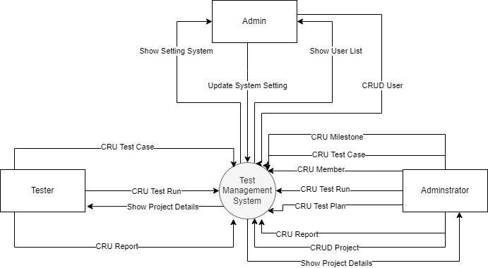

### 1.2 Business Rules

*[Provide common business rules that you must follow. The information can be provided in the table format as the sample below]*

| **ID** | **Rule Definition** |
| --- | --- |
| BR-01 | The customer can only use one email per account. |
| BR-02 | Default user account include:   * Fullname * Email * Password |
| BR-03 | Clear an authorised user session when they logout. |
| BR-04 | The user must have logged in the Test Management System. |
| BR-05 | The system only allows updating information when the user has an active account on the system. |
| BR-06 | Only Administrator role can update project setting |
| BR-07 | Only Administrator role can add member into project |
| BR-08 | Only Administrator role can edit role member in project |
| BR-09 | Each user can have only one role at the time |
| BR-10 | The user information is updated to the system with the inputted information. |
| BR-11 | Only Administrator role can remove member in project |
| BR-12 | Project can have many leader / tester |
| BR-13 | Project can have only one administrator |
| BR-14 | After login to the system, users will be redirected to a specify view based on their role on the system: Administrator, Tester, Webmaster, Leader:  ● If the role is “Administrator”, the system will display the Administrator Dashboard view on a web application.  ● If the role is “Tester”, the system will display the Project list on a web application.  ● If the role is “Webmaster”, the system will display the Webmaster Dashboard on a mobile application.  ● If the role is “Leader”, the system will display the Project list view on a web application. |
| BR-15 | Edit profile for user includes following fields:  ● Fullname  ● Email  ● Password  ● Confirm Password |
| BR-16 | Only Administrator can create project |
| BR-17 | Default project include:   * Project Name * Announcement * Project Type |
| BR-18 | Only Administrator can delete project |
| BR-19 | Default Test Case include:   * Title * Type * Priority * Estimate * References * Automation Type * Precondition * Step * Expected Result |
| BR-20 | Default Milestone include:   * Name, * References, * Parent, * Start date, * End date, * This milestone is completed. |
| BR-21 | Default Test Plane include:   * Name * Milestones * Description * Test Run |
| BR-22 | Default Test Plane include:   * Name * Milestones * Description * Assign To * References |

## 2. User Requirements

### 2.1 Overview

#### a. Use Case Diagram

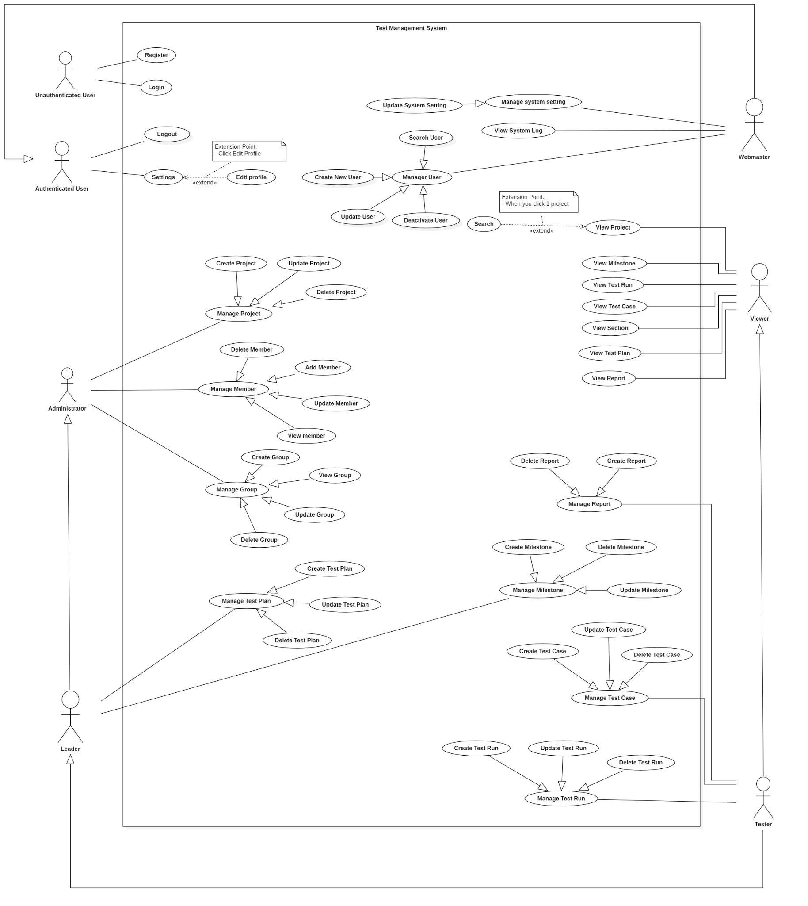

#### b. System Actors

*[An actor is a person (or sometimes another software system or a hardware device) that interacts with the system to perform a use case. Following are some questions you might ask to help user representatives identify actors*

* *Who (or what) is notified when something occurs within the system?*
* *Who (or what) provides information or services to the system?*
* *Who (or what) helps the system respond to and complete a task?*

*This part give the description of system actors, you can follow the table form as below]*

| **#** | **Actor** | **Description** |
| --- | --- | --- |
| 1 | Administrator | Administrator is a user that he / she created a project and has permission to manage project and member |
| 2 | Tester | Tester is a user that has only permission to manage report and test run and test case. |
| 3 | Leader | Leader is a user that has permission to manage test plan and milestone |
| 3 | WebMaster | Webmaster is a user who works directly with the system and has the rights to manage users’ information that exists in the system and the system setting. |
| 4 | Unauthorised User | Unauthorised Users are the users who have not logged into the Test Management System. |
| 5 | Authorised User | Authorised Users are the users who have logged into the Test Management System. |
| 6 | System handler | Third party that handles notification |

#### c. Use Cases List

| **ID** | **Use Case** | **Primary Actors** | **Secondary Actors** | **Third Actor** |
| --- | --- | --- | --- | --- |
| **Authentication** | | | | |
| 01 | Login | Unauthorised User |  |  |
| 02 | Logout | Authorised User |  |  |
| **Manage Profile** | | | | |
| 03 | Get User’s Profile | Authorised User |  |  |
| 04 | Edit Profile | Authorised User |  |  |
| **Manage Project** | | | | |
| 05 | Get Project List | Administrator |  |  |
| 06 | Create Project | Administrator |  |  |
| 07 | Update Project | Administrator |  |  |
| 08 | Delete Project | Administrator |  |  |
| **Manage Member** | | | | |
| 10 | Get Member List | Administrator |  |  |
| 11 | Add Member | Administrator |  |  |
| 12 | Update Member’s Role | Administrator |  |  |
| 13 | Remove Member | Administrator |  |  |
| **Manage Group** | | | | |
| 14 | Get Group List | Administrator |  |  |
| 15 | Add Member | Administrator |  |  |
| 16 | Delete Group | Administrator |  |  |
| 17 | Create Group | Administrator |  |  |
| **Manage Test Case** | | | | |
| 18 | Get Test Case List | Tester | Leader | Administrator |
| 19 | Create Test Case | Tester |  |  |
| 20 | Update Test Case | Tester |  |  |
| 21 | Delete Test Case | Tester |  |  |
| **Manage Milestone** | | | | |
| 22 | Get Milestone List | Leader | Tester | Administrator |
| 23 | Create Milestone | Leader |  |  |
| 24 | Update Milestone | Leader |  |  |
| 25 | Delete Milestone | Leader |  |  |
| **Manage Test Plan** | | | | |
| 26 | Get Test Plan List | Leader | Administrator | Tester |
| 27 | Create Test Plan | Leader |  |  |
| 28 | Update Test Plan | Leader |  |  |
| 29 | Delete Test Plan | Leader |  |  |
| **Manage Test Run** | | | | |
| 30 | Get Test Run List | Tester | Leader | Administrator |
| 31 | Create Test Run | Tester |  |  |
| 32 | Update Test Run | Tester |  |  |
| 33 | Delete Test Run | Tester |  |  |
| **Manage Report** | | | | |
| 34 | Get Report List | Tester | Leader | Administrator |
| 35 | Create Report | Tester | Leader |  |
| 36 | Update Report | Tester | Leader |  |
| 37 | Delete Report | Tester | Leader |  |
| **Manage User** | | | | |
| 38 | Get User List | WebMaster |  |  |
| 39 | Search User | WebMaster |  |  |
| 40 | Create New User | WebMaster |  |  |
| 41 | Deactivate User | WebMaster |  |  |
| 42 | Activate User | WebMaster |  |  |
| **Manage System** | | | | |
| 43 | View System’s Log | WebMaster |  |  |
| 44 | Update System Setting | WebMaster |  |  |

### 

### 

### 2.2 Authentication

#### 

#### a. Login*.*

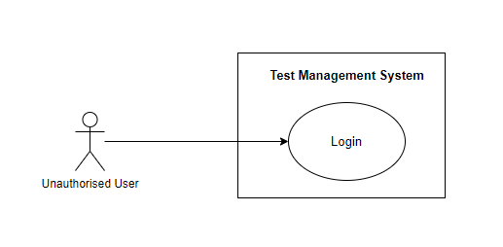

*Figure 1. <Use case>Login*

| UC ID and Name: | UC 01.Login | | |
| --- | --- | --- | --- |
| Created By: | Hoàng Lê Duy | Date Created: | 21/10/2022 |
| Primary Actor: | Unauthorised User | Secondary Actors: | N/A |
| Trigger: | An Unauthorised user sends a request to login into the Test Management System. | | |
| Description: | This use case allows the Actor to login his/her account into the system to use more features. | | |
| Preconditions: | **PRE-1**: The actor needs an account in the system.  **PRE-2**: The actor must use a web application to login into the system (Admin). | | |
| Post-conditions: | **POST-1**: Move to Overview Page | | |
| Normal Flow: | **1.0 Login**   1. **TMS** show button “Login” a form that required actor to fill:  - “Email”: text input, blank, required.  - “Password”: text input, blank, required. 2. **Actor** fills the email and password to login form (see 2.0.E1, 2.0.E2...). 3. **Actor** clicks the “Login”button to send a request to login to the system. 4. **TMS** system validates the information and navigation to the home screen for each role. | | |
| Alternative Flows: | **N/A** | | |
| Exceptions: | **2.0. E1 The actor falls fill in all the text field**  - **TMS** returns to the actor to fill the missing field.  - If the actor input fields again, return to step 3 of normal flow.  **2.0. E2 The actor fills field not validate**  - **TMS** required the actor to fill the field again. If the actor refills the fields, return to step 3 of normal flow. | | |
| Priority: | High | | |
| Frequency of Use: | High | | |
| Business Rules: | **BR-14**: After login to the system, users will be redirected to a specify view based on their role on the system: Administrator, Tester, Webmaster, Leader:  ● If the role is “Administrator”, the system will display the Administrator Dashboard view on a web application.  ● If the role is “Tester”, the system will display the Project list on a web application.  ● If the role is “Webmaster”, the system will display the Webmaster Dashboard on a mobile application.  ● If the role is “Leader”, the system will display the Project list view on a web application. | | |
| Other Information: | N/A | | |
| Assumptions: | Users must have an account already registered in the TMS. | | |

#### 

#### b. Logout

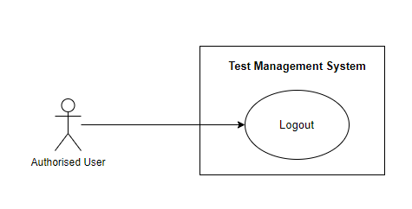

*Figure 2. <Use case>Logout*

#### 

| UC ID and Name: | UC 02.Logout | | |
| --- | --- | --- | --- |
| Created By: | Hoàng Lê Duy | Date Created: | 21/10/2022 |
| Primary Actor: | Authorised User | Secondary Actors: | N/A |
| Trigger: | Authorised user sends a request to logout the TMS. | | |
| Description: | This use case allows the Actor to logout his/her account in the system. | | |
| Preconditions: | **PRE-1**: The actor needs an account in the system.  **PRE-2**: The actor must be logged into the system. | | |
| Post-conditions: | **POST-1**: System remove user session and navigator to login screen | | |
| Normal Flow: | **2.0 Logout**   1. **Authorised user** clicks on Username. 2. **TMS** shows a dropdown list. 3. **Authorised User** clicks “Logout” button. 4. **TMS** delete their session. 5. **TMS** navigates the actor to the login page | | |
| Alternative Flows: | N/A | | |
| Exceptions: | N/A | | |
| Priority: | Medium | | |
| Frequency of Use: | Medium | | |
| Business Rules: | **BR-03:** Clear an authorised user session when they logout. | | |
| Other Information: | N/A | | |
| Assumptions: | N/A | | |

### 

### 2.3 Manage Profile

#### 

#### a. Get personal profile.

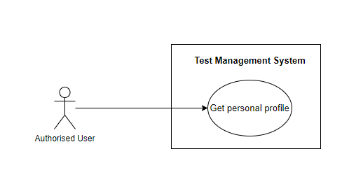

*Figure 3. <Use case>Get personal profile*

| UC ID and Name: | UC 03.Get personal profile | | |
| --- | --- | --- | --- |
| Created By: | Hoàng Lê Duy | Date Created: | 21/10/2022 |
| Primary Actor: | Authorised User | Secondary Actors: | TMS |
| Trigger: | An Authorised user sends a request to get all their information in the Car Service System. | | |
| Description: | This use case allows authorised users to view their profile. | | |
| Preconditions: | **PRE-1**: The actor already logged into the TMS. | | |
| Post-conditions: | **POST-1**: System navigator to profile screen | | |
| Normal Flow: | **3.0 Get personal profile**   1. **Authorised user** send a request to get their information. 2. **TMS** returns profile screen. | | |
| Alternative Flows: | **N/A** | | |
| Exceptions: | **N/A** | | |
| Priority: | Low | | |
| Frequency of Use: | Low | | |
| Business Rules: | **BR-04**: The user must have logged in the Test Management System. | | |
| Other Information: | N/A | | |
| Assumptions: | Users must have an account already registered in the TMS. | | |

#### 

#### b. Edit profile

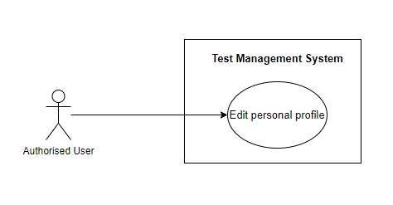

*Figure 4. <Use case>Edit personal profile*

#### 

| UC ID and Name: | UC 04.Edit profile | | |
| --- | --- | --- | --- |
| Created By: | Hoàng Lê Duy | Date Created: | 21/10/2022 |
| Primary Actor: | Authorised User | Secondary Actors: | TMS |
| Trigger: | An Authorised user sends a request to edit their information in the TMS. | | |
| Description: | This use case allows authorised users to edit their profile. | | |
| Preconditions: | **PRE-1**: The actor already logged into the TMS.  **PRE-2**: The actor already view their profile | | |
| Post-conditions: | **POST-1**: TMS navigator to profile screen | | |
| Normal Flow: | **4.0 Edit profile**   1. **Authorised user** clicks on Username. 2. **TMS** shows a dropdown list. 3. **Authorised User** clicks “My Setting” button. 4. **TMS** navigates the actor to the profile page. 5. TMS requires information from ( See 4.0.E1):  - Fullname: text input, required.  - Email: text input, required.  - Password: text input, required.  - Confirm password: text required. 6. **Authorised user** input to edit form: Fullname, Email, Password, Confirm Password. 7. **a. Authorised user** click the “Save User” button. b. **Authorised user** clicks on the “Cancel” button, **TMS** return to dashboard page 8. **a. TMS** validates the Full Name, Email, Password, Confirm password (see 4.0.E1, 4.0.E2). 9. **a .TMS** will store information details and update information. | | |
| Alternative Flows: | **N/A** | | |
| Exceptions: | **4.0 E1 The actor falls fill in all the text field**  - The TMS system returns to the actor to fill the missing field.  - The actor input fields again, returning to step 6 of normal flow.  **4.0 E2 The actor fills field not validate**  - The TMS required actor fills field again  - The actor refills the fields, returning to step 6 of normal flow. | | |
| Priority: | Medium | | |
| Frequency of Use: | Medium | | |
| Business Rules: | **BR-04**. The user must have logged in the Test Management System.  **BR-05**: The system only allows updating information when the user has an active account on the system.  **BR-15**: Edit profile for employee includes following fields:  ● Fullname  ● Email  ● Password  ● Confirm Password  **BR-10**: The user information is updated to the system with the inputted information. | | |
| Other Information: | N/A | | |
| Assumptions: | N/A | | |

#### 

### 2.4 Manage Project

#### a. Get Project List

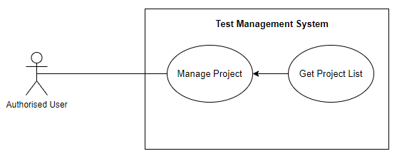

*Figure 5. <Use case>Get Project List*

| UC ID and Name: | UC 05.Get Project List | | |
| --- | --- | --- | --- |
| Created By: | Hoàng Lê Duy | Date Created: | 21/10/2022 |
| Primary Actor: | Authorised User | Secondary Actors: | TMS |
| Trigger: | An Authorised user sends a request to get all project list in the TMS. | | |
| Description: | This use case allows authorised users to view the project list available. | | |
| Preconditions: | **PRE-1**: The actor already logged into the TMS. | | |
| Post-conditions: | **POST-1**: The list of project is returned to the actor who sends the request to view the project list | | |
| Normal Flow: | **5.0 Get Project List**   1. **Administrator** send a request to get project list 2. **TMS** returns a list project. | | |
| Alternative Flows: | **N/A** | | |
| Exceptions: | **N/A** | | |
| Priority: | Medium | | |
| Frequency of Use: | Medium | | |
| Business Rules: | **BR-04**: The user must have logged in the Test Management System. | | |
| Other Information: | N/A | | |
| Assumptions: | Users must have an account already registered in the TMS. | | |

#### b. Create Project

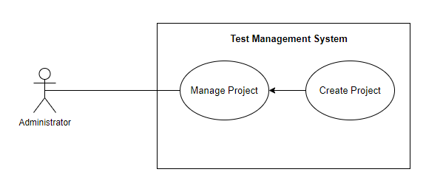

*Figure 6. <Use case>Create Project*

| UC ID and Name: | UC 06.Create Project | | |
| --- | --- | --- | --- |
| Created By: | Hoàng Lê Duy | Date Created: | 21/10/2022 |
| Primary Actor: | Administrator | Secondary Actors: | TMS |
| Trigger: | Administrator sends a request to create a project in the TMS. | | |
| Description: | This use case allows the actor to create the new project . | | |
| Preconditions: | **PRE-1**: The actor already logged into the TMS  **PRE-2**: The actor must login with the administrator role. | | |
| Post-conditions: | **POST-1**: A new project will be created | | |
| Normal Flow: | **6.0 Create Project**   1. **Administrator** clicks the “Add Project” button on the dashboard. 2. **TMS** will pop up to create project screen ( See 6.0.AF1): 3. **TMS** required information from Administrator: - Project Name: text input, blank, required. - Announcement: text, input, blank, required. - Project Type: select, blank, required  + Use a single repository for all cases  + Use a single repository with baseline support.  + Use multiple test suites to manage cases. 4. **Administrator** input to create project form: Project Name, Announcement, select type of project. 5. **a. Administrator** clicks the “Create Project” button. **b**. **Administrator** clicks the “Cancel” button, **TMS** returns to the dashboard page. 6. **a. TMS** will validate the Project Name, Announcement, Project type ( See 6.0.E1, 6.0.E2). 7. **a. TMS** will stores information details and create new project. | | |
| Alternative Flows: | **N/A** | | |
| Exceptions: | **6.0 E1 The actor falls fill in all the text field**  - The TMS system returns to the actor to fill the missing field.  - The actor input fields again, returning to step 4 of normal flow.  **6.0 E2 The actor fills field not validate**  - The TMS required actor fills field again  - The actor refills the fields, returning to step 4 of normal flow. | | |
| Priority: | High | | |
| Frequency of Use: | Medium | | |
| Business Rules: | **BR-04**: The user must have logged in the Test Management System.  **BR-16**: Only Administrator can create project.  **BR-17:** Default project include:   * Project Name * Announcement * Project Type | | |
| Other Information: | N/A | | |
| Assumptions: | N/A | | |

#### 

#### c. Update Project

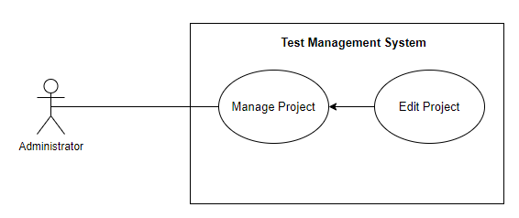

*Figure 7. <Use case>Edit Project*

| UC ID and Name: | UC 07. Update Project | | |
| --- | --- | --- | --- |
| Created By: | Hoàng Lê Duy | Date Created: | 21/10/2022 |
| Primary Actor: | Administrator | Secondary Actors: | TMS |
| Trigger: | Administrator sends a request to update a project in the TMS. | | |
| Description: | This use case allows the actor to update projects . | | |
| Preconditions: | **PRE-1**: The actor already logged into the TMS  **PRE-2**: The actor must login with the administrator role. | | |
| Post-conditions: | **POST-1**: The project will be updated | | |
| Normal Flow: | **7.0 Update Project**   1. **Administrator** clicks the edit icon button on a specific project. 2. **TMS** will pop up to create project screen: 3. **TMS** required information from Administrator: - Project Name: text input, blank, required. - Announcement: text, input, blank, required. - Project Type: select, blank, required  + Use a single repository for all cases  + Use a single repository with baseline support.  + Use multiple test suites to manage cases. 4. **Administrator** input to update project form: Project Name, Announcement, select type of project. 5. **a. Administrator** clicks the “Save Project” button. **b. Administrator** clicks the “Cancel” button, **TMS** returns to the dashboard page. 6. **a. TMS** will validate the Project Name, Announcement, Project type ( See 7.0.E1, 7.0.E2). 7. **a. TMS** will stores information details and update project. | | |
| Alternative Flows: | N/A | | |
| Exceptions: | **7.0 E1 The actor falls fill in all the text field**  - The TMS system returns to the actor to fill the missing field.  - The actor input fields again, returning to step 4 of normal flow.  **7.0 E2 The actor fills field not validate**  - The TMS required actor fills field again  - The actor refills the fields, returning to step 4 of normal flow. | | |
| Priority: | High | | |
| Frequency of Use: | Medium | | |
| Business Rules: | **BR-04**: The user must have logged in the Test Management System.  **BR-06**: Only Administrator can update project.  **BR-17:** Default project include:   * Project Name * Announcement * Project Type | | |
| Other Information: | N/A | | |
| Assumptions: | N/A | | |

#### 

#### d. Delete Project

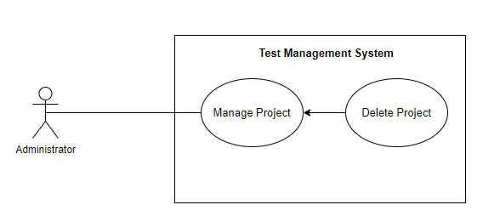

*Figure 8. <Use case>Delete Project*

| UC ID and Name: | UC 08. Delete Project | | |
| --- | --- | --- | --- |
| Created By: | Hoàng Lê Duy | Date Created: | 21/10/2022 |
| Primary Actor: | Administrator | Secondary Actors: | TMS |
| Trigger: | Administrator sends a request to delete a project in the TMS. | | |
| Description: | This use case allows the actor to delete projects . | | |
| Preconditions: | **PRE-1**: The actor already logged into the TMS  **PRE-2**: The actor must login with the administrator role. | | |
| Post-conditions: | **POST-1**: The project will be deleted | | |
| Normal Flow: | **8.0 Delete Project**   1. **Administrator** clicks the delete icon button on a specific project. 2. **TMS** shows a delete popup with the Confirm message with two buttons for admin can select: - “OK” button - “Cancel” button 3. a. **Administrator** clicks on the “OK” button, **TMS** remove project   b. **Administrator** clicks on the “Cancel” button, **TMS** closes and nothing change. | | |
| Alternative Flows: | **N/A** | | |
| Exceptions: | **N/A** | | |
| Priority: | Low | | |
| Frequency of Use: | Low | | |
| Business Rules: | **BR-18:** Only Administrator can delete project | | |
| Other Information: | N/A | | |
| Assumptions: | N/A | | |

#### 

### 2.5 Manage Member

#### a. Get Member List

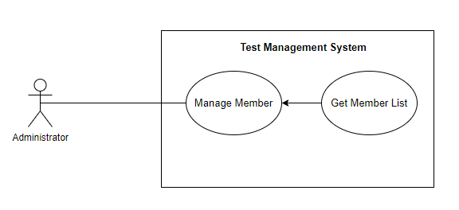

*Figure 9. <Use case>Get Member List*

| UC ID and Name: | UC 09.Get Member List | | |
| --- | --- | --- | --- |
| Created By: | Hoàng Lê Duy | Date Created: | 21/10/2022 |
| Primary Actor: | Administrator | Secondary Actors: | TMS |
| Trigger: | Administrator sends a request to get a member list in the project. | | |
| Description: | This use case allows Administrator to view the member list available. | | |
| Preconditions: | **PRE-1**: The actor already logged into the TMS.  **PRE-2**: The actor must login with Administrator role | | |
| Post-conditions: | **POST-1**: The list of project is returned to the actor who sends the request to view the member list | | |
| Normal Flow: | **9.0 Get Member List**   1. **Administrator** clicks the edit icon button for the specific project. 2. **Administrator** clicks the tab User 3. **Administrator** send a request to get member list 4. **TMS** returns a list member. | | |
| Alternative Flows: | **N/A** | | |
| Exceptions: | **N/A** | | |
| Priority: | Medium | | |
| Frequency of Use: | Medium | | |
| Business Rules: | **BR-04**: The user must have logged in the Test Management System. | | |
| Other Information: | N/A | | |
| Assumptions: | N/A | | |

#### 

#### b. Add Member

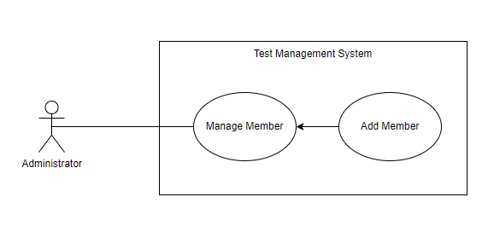

*Figure 10. <Use case>Add Member*

#### 

| UC ID and Name: | UC 10.Add Member | | |
| --- | --- | --- | --- |
| Created By: | Hoàng Lê Duy | Date Created: | 21/10/2022 |
| Primary Actor: | Administrator | Secondary Actors: | TMS |
| Trigger: | Administrator sends a request to add a member to the project in the TMS. | | |
| Description: | This use case allows the actor to add a member to the project . | | |
| Preconditions: | **PRE-1**: The actor already logged into the TMS  **PRE-2**: The actor must login with the administrator role. | | |
| Post-conditions: | **POST-1**: A new member will be added into the project. | | |
| Normal Flow: | **10.0 Add Member**   1. **Administrator** clicks the edit icon button for the specific project. 2. **Administrator** clicks the tab User 3. **Administrator** clicks the “Add User” button. 4. **TMS**  will pop up to add member screen. 5. **TMS** required information from **Administrator**: - Full Name: text input, blank, required. - Email: text, input, blank, required. - Role: dropdown list, required.  + Lead  + Tester  + Viewer - Password: text input, blank, required. - Confirm password, text input, blank, required. 6. **Administrator** input to update project form: Full Name, Email, select Role, Password and Confirm password. 7. **a. Administrator** clicks the “Save User” button. **b. Administrator** clicks the “Cancel” button, **TMS** returns to the dashboard page. 8. **a. TMS** will validate the Full Name,Email, Role, Password, Confirm password. ( See 10.0.E1, 10.0.E2). 9. **a. TMS** will store information details and add member. | | |
| Alternative Flows: | **N/A** | | |
| Exceptions: | **10.0 E1 The actor falls fill in all the text field**  - The TMS system returns to the actor to fill the missing field.  - The actor input fields again, returning to step 6 of normal flow.  **10.0 E2 The actor fills field not validate**  - The TMS required actor fills field again  - The actor refills the fields, returning to step 6 of normal flow. | | |
| Priority: | Medium | | |
| Frequency of Use: | Medium | | |
| Business Rules: | **BR-04**: The user must have logged in the Test Management System.  **BR-07**: Only Administrator role can add member into project  **BR-02:** Default user account include:   * Fullname * Email * Password   **BR-12**: Project can have many leader / tester | | |
| Other Information: | N/A | | |
| Assumptions: | N/A | | |

#### 

#### 

#### c. Edit Member

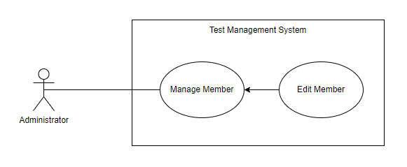

*Figure 11. <Use case>Edit Member*

| UC ID and Name: | UC 11.Edit Member | | |
| --- | --- | --- | --- |
| Created By: | Hoàng Lê Duy | Date Created: | 21/10/2022 |
| Primary Actor: | Administrator | Secondary Actors: | TMS |
| Trigger: | Administrator sends a request to edit a member in the project in the TMS. | | |
| Description: | This use case allows the actor to edit a member to the project . | | |
| Preconditions: | **PRE-1**: The actor already logged into the TMS  **PRE-2**: The actor must login with the administrator role. | | |
| Post-conditions: | **POST-1**: A member will be edited | | |
| Normal Flow: | **11.0 Edit Member**   1. **Administrator** clicks the edit icon button for the specific project. 2. **Administrator** clicks the “User” tab. 3. **Administrator** clicks the edit icon button for the specific member. 4. **TMS**  will pop up to edit the member screen. 5. **TMS** required information from **Administrator**: - Full Name: text input, blank, required. - Email: text, input, blank, required. - Role: dropdown list, required.  + Lead  + Tester  + Viewer - Password: text input, blank, required. - Confirm password, text input, blank, required. 6. **Administrator** input to update project form: Full Name, Email, select Role, Password and Confirm password. 7. **a. Administrator** clicks the “Save User” button. **b. Administrator** clicks the “Cancel” button, **TMS** returns to the dashboard page. 8. **a. TMS** will validate the Full Name,Email, Role, Password, Confirm password. ( See 10.0.E1, 10.0.E2). 9. **a. TMS** will store information details and update member. | | |
| Alternative Flows: | **N/A** | | |
| Exceptions: | **11.0 E1 The actor falls fill in all the text field**  - The TMS system returns to the actor to fill the missing field.  - The actor input fields again, returning to step 6 of normal flow.  **11.0 E2 The actor fills field not validate**  - The TMS required actor fills field again  - The actor refills the fields, returning to step 6 of normal flow. | | |
| Priority: | Medium | | |
| Frequency of Use: | Medium | | |
| Business Rules: | **BR-04**: The user must have logged in the Test Management System.  **BR-08**: Only Administrator role can update role member  **BR-02:** Default user account include:   * Fullname * Email * Password   **BR-12**: Project can have many leader / tester  **BR-10**: The user information is updated to the system with the inputted information. | | |
| Other Information: | N/A | | |
| Assumptions: | N/A | | |

#### 

#### 

#### d. Remove Member

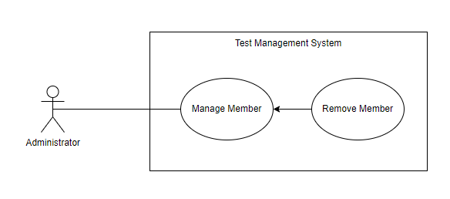

*Figure 12. <Use case>Remove Member*

| UC ID and Name: | UC 12. Remove Member | | |
| --- | --- | --- | --- |
| Created By: | Hoàng Lê Duy | Date Created: | 21/10/2022 |
| Primary Actor: | Administrator | Secondary Actors: | TMS |
| Trigger: | Administrator sends a request to a member in the project. | | |
| Description: | This use case allows the actor to remove member . | | |
| Preconditions: | **PRE-1**: The actor already logged into the TMS  **PRE-2**: The actor must login with the administrator role. | | |
| Post-conditions: | **POST-1**: A Member will be removed | | |
| Normal Flow: | **12.0 Remove Member**   1. **Administrator** clicks the edit icon button for the specific project. 2. **Administrator** clicks the “User” tab. 3. **Administrator** clicks the delete icon button on a specific member. 4. **TMS** shows a delete popup with the Confirm message with two buttons for admin can select: - “OK” button - “Cancel” button 5. a. **Administrator** clicks on the “OK” button, **TMS** remove member   b. **Administrator** clicks on the “Cancel” button, **TMS** closes and nothing changes. | | |
| Alternative Flows: | **N/A** | | |
| Exceptions: | **N/A** | | |
| Priority: | Low | | |
| Frequency of Use: | Low | | |
| Business Rules: | **BR-11:** Only Administrator role can remove member in project | | |
| Other Information: | N/A | | |
| Assumptions: | N/A | | |

#### 

### 2.6 Manage Group

#### a. Add Group

#### 

| ID and Name: | **UC-01 Add a Test Case** | | |
| --- | --- | --- | --- |
|  |  | | |
| Created By: | Hoàng Lê Duy | Date Created: | 7/10/2022 |
| Primary Actor: | Tester | Secondary Actors: | Test Management System |
| Description: | A Tester accesses the Test Management System from the corporate intranet or from home, the leader asks to edit a test case for a specific date.. | | |
| Trigger: | A Tester asked to edit a test case for the project | | |
| Preconditions: | PRE-1. Tester is logged into TMS. | | |
| Post-conditions: | POST-1. Test case is available in project | | |
| Normal Flow: | **1.0 Edit a Test Case**   1. Tester view dashboard of project 2. Tester clicks the “Test Case” tab. 3. TMS display all test case available in project 4. Tester clicks on a test case he wants to edit. 5. TMS display clicked test case details. 6. Tester clicks the “Edit” button. 7. TMS displays:  Title: text  Section: dropdown list  Template: dropdown list  Type: dropdown list  Priority: dropdown list  Estimate: text  References: text  Automation Type: dropdown list  Precondition: text  Steps: text  Expected Result: text 8. Tester edited what he asked to edit. 9. Tester clicks the “Save Test Case” button. 10. TMS displays Title, Section, Template, Type, Priority, Estimate, References, Automation Type, Precondition, Steps, Expected Result of clicked Test Case. | | |
| Alternative Flows: | N/A | | |
| Exceptions: |  | | |
| Priority: | Medium | | |
| Frequency of Use: | Medium | | |
| Business Rules: |  | | |
| Other Information: | N/A | | |
| Assumptions: | N/A | | |

#### 

#### b. Edit Group

| ID and Name: | **UC-01 Edit a Test Case** | | |
| --- | --- | --- | --- |
|  |  | | |
| Created By: | Hoàng Lê Duy | Date Created: | 7/10/2022 |
| Primary Actor: | Tester | Secondary Actors: | Test Management System |
| Description: | A Tester accesses the Test Management System from the corporate intranet or from home, the leader asks to edit a test case for a specific date.. | | |
| Trigger: | A Tester asked to edit a test case for the project | | |
| Preconditions: | PRE-1. Tester is logged into TMS. | | |
| Post-conditions: | POST-1. Test case is available in project | | |
| Normal Flow: | **1.0 Edit a Test Case**   1. Tester view dashboard of project 2. Tester clicks the “Test Case” tab. 3. TMS display all test case available in project 4. Tester clicks on a test case he wants to edit. 5. TMS display clicked test case details. 6. Tester clicks the “Edit” button. 7. TMS displays:  Title: text  Section: dropdown list  Template: dropdown list  Type: dropdown list  Priority: dropdown list  Estimate: text  References: text  Automation Type: dropdown list  Precondition: text  Steps: text  Expected Result: text 8. Tester edited what he asked to edit. 9. Tester clicks the “Save Test Case” button. 10. TMS displays Title, Section, Template, Type, Priority, Estimate, References, Automation Type, Precondition, Steps, Expected Result of clicked Test Case. | | |
| Alternative Flows: | N/A | | |
| Exceptions: |  | | |
| Priority: | Medium | | |
| Frequency of Use: | Medium | | |
| Business Rules: |  | | |
| Other Information: | N/A | | |
| Assumptions: | N/A | | |

#### 

#### c. Delete Group

### 2.7 Manage Test Case

#### a. Get List Test Case

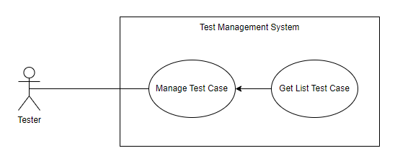

*Figure 16. <Use case>Get List Test Case*

| UC ID and Name: | UC 16.Get Test Case List | | |
| --- | --- | --- | --- |
| Created By: | Hoàng Lê Duy | Date Created: | 21/10/2022 |
| Primary Actor: | Tester | Secondary Actors: | TMS |
| Trigger: | The actor sends a request to get all test case in the project. | | |
| Description: | This use case allows authorised users to view the test case list available. | | |
| Preconditions: | **PRE-1**: The actor already logged into the TMS. | | |
| Post-conditions: | **POST-1**: The list of test case is returned to the actor who sends the request to view the test case list | | |
| Normal Flow: | **16.0 Get Project List**   1. **Tester** clicks the specific project. 2. **Tester** clicks the tab Test Case 3. **Tester** send a request to get test case list 4. **TMS** returns a list test case. | | |
| Alternative Flows: | **N/A** | | |
| Exceptions: | **N/A** | | |
| Priority: | Medium | | |
| Frequency of Use: | Medium | | |
| Business Rules: | **BR-04**: The user must have logged in the Test Management System. | | |
| Other Information: | N/A | | |
| Assumptions: | N/A | | |

#### 

#### b. Add Test Case

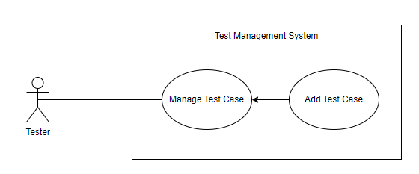

*Figure 17. <Use case>Add Test Case*

#### 

| ID and Name: | **UC-17 Add a Test Case** | | |
| --- | --- | --- | --- |
| Created By: | Hoàng Lê Duy | Date Created: | 7/10/2022 |
| Primary Actor: | Tester | Secondary Actors: | TMS |
| Description: | This use case allows authorised users to add a test case. | | |
| Trigger: | The actor sends a request to add a test case in the project. | | |
| Preconditions: | PRE-1. Tester is logged into TMS. | | |
| Post-conditions: | POST-1. A Test case will be created in project | | |
| Normal Flow: | **17.0Add Test Case**   1. **Tester** clicks the specific project. 2. **Tester** clicks the tab Test Case 3. **Tester** clicks the “Add Test Case” button. 4. **TMS**  will pop up to add test case screen. 5. **TMS** required information from **Tester**: - Title: text input, blank, required - Type: drop down list, blank, required - Priority: drop down list, blank, required - Estimate: text input, blank, required - References: text input, blank, required - Automation Type: drop down list, blank, required - Precondition: text input, blank, required. - Step: text input, blank, required. - Expected Result: text input, blank, required 6. **Tester** input to update project form: Title, Type, Priority, Estimate, References, Automation Type, Precondition, Step. 7. **a. Tester** clicks the “Save Test Case” button. **b. Tester** clicks the “Cancel” button, **TMS** returns to the dashboard page. 8. **a. TMS** will validate the Title, Type, Priority, Estimate, References, Automation Type, Precondition, Step, Expected Result. ( See 17.0.E1). 9. **a. TMS** will store information details and add test case. | | |
| Alternative Flows: | N/A | | |
| Exceptions: | **17.0 E1 The actor falls fill in all the text field**  - The TMS system returns to the actor to fill the missing field.  - The actor input fields again, returning to step 6 of normal flow.  **17.0 E2 The actor fills field not validate**  - The TMS required actor fills field again  - The actor refills the fields, returning to step 6 of normal flow. | | |
| Priority: | Medium | | |
| Frequency of Use: | Medium | | |
| Business Rules: | **BR-19:** Default project include:   * Title * Type * Priority * Estimate * References * Automation Type * Precondition * Step * Expected Result | | |
| Other Information: | N/A | | |
| Assumptions: | N/A | | |

#### 

#### c. Edit a Test Case

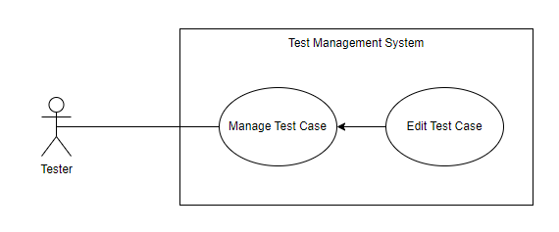

*Figure 18. <Use case>Edit Test Case*

#### 

| ID and Name: | **UC-18 Edit Test Case** | | |
| --- | --- | --- | --- |
| Created By: | Hoàng Lê Duy | Date Created: | 7/10/2022 |
| Primary Actor: | Tester | Secondary Actors: | TMS |
| Description: | This use case allows authorised users to edit a test case. | | |
| Trigger: | The actor sends a request to edit a test case in the project. | | |
| Preconditions: | PRE-1. Tester is logged into TMS. | | |
| Post-conditions: | POST-1. A Test case will be edited in project | | |
| Normal Flow: | **18.0 Edit Test Case**   1. **Tester** clicks the specific project. 2. **Tester** clicks the tab Test Case 3. **Tester** clicks the specific test case. 4. **TMS**  will pop up to edit the test case screen. 5. **TMS** required information from **Tester**: - Title: text input, blank, required - Type: drop down list, blank, required - Priority: drop down list, blank, required - Estimate: text input, blank, required - References: text input, blank, required - Automation Type: drop down list, blank, required - Precondition: text input, blank, required. - Step: text input, blank, required. - Expected Result: text input, blank, required 6. **Tester** input to update project form: Title, Type, Priority, Estimate, References, Automation Type, Precondition, Step, Expected Result. 7. **a. Tester** clicks the “Save Test Case” button. **b. Tester** clicks the “Cancel” button, **TMS** returns to the dashboard page. 8. **a. TMS** will validate the Title, Type, Priority, Estimate, References, Automation Type, Precondition, Step. ( See 17.0.E1). 9. **a. TMS** will store information details and update test case. | | |
| Alternative Flows: | N/A | | |
| Exceptions: | **17.0 E1 The actor falls fill in all the text field**  - The TMS system returns to the actor to fill the missing field.  - The actor input fields again, returning to step 6 of normal flow.  **17.0 E2 The actor fills field not validate**  - The TMS required actor fills field again  - The actor refills the fields, returning to step 6 of normal flow. | | |
| Priority: | Medium | | |
| Frequency of Use: | Medium | | |
| Business Rules: | **BR-19:** Default project include:   * Title * Type * Priority * Estimate * References * Automation Type * Precondition * Step * Expected Result | | |
| Other Information: | N/A | | |
| Assumptions: | N/A | | |

#### d. Delete Test Case

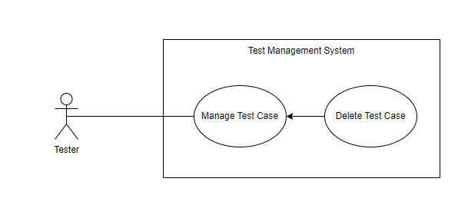

*Figure 19. <Use case>Delete Test Case*

#### 

| ID and Name: | **UC-19 Delete Test Case** | | |
| --- | --- | --- | --- |
| Created By: | Hoàng Lê Duy | Date Created: | 7/10/2022 |
| Primary Actor: | Tester | Secondary Actors: | TMS |
| Description: | This use case allows authorised users to delete a test case. | | |
| Trigger: | The actor sends a request to delete a test case in the project. | | |
| Preconditions: | PRE-1. Tester is logged into TMS. | | |
| Post-conditions: | POST-1. A Test case will be remove in project | | |
| Normal Flow: | **19.0. Delete Test Case**   1. **Tester** clicks the specific project. 2. **Tester** clicks the tab Test Case 3. **Tester** clicks the specific test case. 4. **TMS** shows a delete popup with the Confirm message with two buttons for **Tester** can select: - “OK” button - “Cancel” button 5. a. **Tester** clicks on the “OK” button, **TMS** remove member   b. **Tester** clicks on the “Cancel” button, **TMS** closes and nothing changes. | | |
| Alternative Flows: | N/A | | |
| Exceptions: | **N/A** | | |
| Priority: | Medium | | |
| Frequency of Use: | Medium | | |
| Business Rules: | **BR-04**: The user must have logged in the Test Management System | | |
| Other Information: | N/A | | |
| Assumptions: | N/A | | |

## 

### 2.8 Manage Milestone

#### a. Get List Milestone

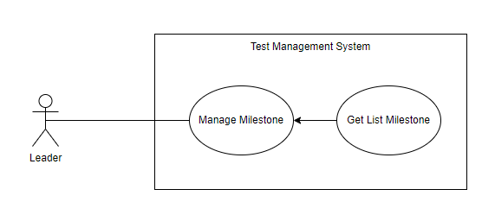

*Figure 20. <Use case>Get List Milestone*

| UC ID and Name: | UC 20.Get Milestone List | | |
| --- | --- | --- | --- |
| Created By: | Hoàng Lê Duy | Date Created: | 21/10/2022 |
| Primary Actor: | Leader | Secondary Actors: | TMS |
| Trigger: | The actor sends a request to get all milestones in the project. | | |
| Description: | This use case allows authorised users to view the milestone list available. | | |
| Preconditions: | **PRE-1**: The actor already logged into the TMS. | | |
| Post-conditions: | **POST-1**: The list of test case is returned to the actor who sends the request to view the test case list | | |
| Normal Flow: | **20.0 Get Milestones List**   1. **Leader** clicks the specific project. 2. **Leader** clicks the tab Milestone 3. **Leader** send a request to get milestone list 4. **TMS** returns a list milestone. | | |
| Alternative Flows: | **N/A** | | |
| Exceptions: | **N/A** | | |
| Priority: | Medium | | |
| Frequency of Use: | Medium | | |
| Business Rules: | **BR-04**: The user must have logged in the Test Management System. | | |
| Other Information: | N/A | | |
| Assumptions: | N/A | | |

#### 

#### b. Add Milestone

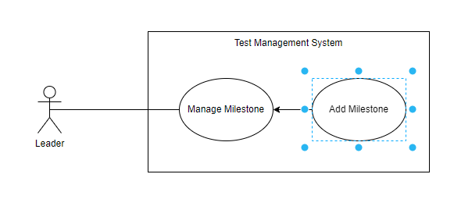

*Figure 21. <Use case>Add Milestones*

#### 

| ID and Name: | **UC-21 Add Milestones** | | |
| --- | --- | --- | --- |
| Created By: | Hoàng Lê Duy | Date Created: | 7/10/2022 |
| Primary Actor: | **Leader** | Secondary Actors: | TMS |
| Description: | This use case allows authorised users to add a test case. | | |
| Trigger: | The actor sends a request to add a test case in the project. | | |
| Preconditions: | PRE-1. Tester is logged into TMS. | | |
| Post-conditions: | POST-1. A Test case will be created in project | | |
| Normal Flow: | **21.0 Add Milestones**   1. **Leader** clicks the specific project. 2. **Leader** clicks the tab Milestones 3. **Leader** clicks the “Add Milestones” button. 4. **TMS**  will pop up to add milestones screen. 5. **TMS** required information from **Leader**: - Name: text input, blank, required  - References: text input, blank, required. - Parent: drop down list, blank, required. - Description: text input, blank, required - Start date: text input, blank, required - End date: text input, blank, required - This milestones is completed: check box 6. **Leader** input to update project form:Name, References, Parent, Start date, End date, This milestone is completed. 7. **a. Leader** clicks the “Add Milestones” button. **b. Leader** clicks the “Cancel” button, **TMS** returns to the dashboard page. 8. **a. TMS** will validate the Name, References, Parent, Start date, End date, This milestone is completed. ( See 21.0.E1, 21.0.E2 ). 9. **a. TMS** will store information details and add milestones. | | |
| Alternative Flows: | N/A | | |
| Exceptions: | **21.0 E1 The actor falls fill in all the text field**  - The TMS system returns to the actor to fill the missing field.  - The actor input fields again, returning to step 6 of normal flow.  **21.0 E2 The actor fills field not validate**  - The TMS required actor fills field again  - The actor refills the fields, returning to step 6 of normal flow. | | |
| Priority: | Medium | | |
| Frequency of Use: | Medium | | |
| Business Rules: | **BR-20:** Default Milestone include:   * Name, * References, * Parent, * Start date, * End date, * This milestone is completed. | | |
| Other Information: | N/A | | |
| Assumptions: | N/A | | |

#### 

#### c. Edit a Milestones

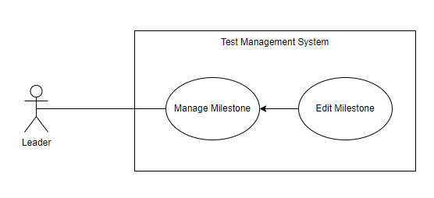

*Figure 22. <Use case>Edit Milestone*

#### 

| ID and Name: | **UC-22 Edit Milestones** | | |
| --- | --- | --- | --- |
| Created By: | Hoàng Lê Duy | Date Created: | 7/10/2022 |
| Primary Actor: | Leader | Secondary Actors: | TMS |
| Description: | This use case allows authorised users to edit a milestone. | | |
| Trigger: | The actor sends a request to edit milestones in the project. | | |
| Preconditions: | PRE-1. Leader is logged into TMS. | | |
| Post-conditions: | POST-1. A Milestones will be edited in project | | |
| Normal Flow: | **22.0 Edit Milestone**   1. **Leader** clicks the specific project. 2. **Leader** clicks the tab milestones 3. **Leader** clicks the specific milestones. 4. **TMS**  will pop up to edit the milestones screen. 5. **TMS** required information from **Leader**: - Name: text input, blank, required  - References: text input, blank, required. - Parent: drop down list, blank, required. - Description: text input, blank, required - Start date: text input, blank, required - End date: text input, blank, required - This milestones is completed: check box 6. **Leader** input to update project form:Name, References, Parent, Start date, End date, This milestone is completed. 7. **a. Leader** clicks the “Save Milestones” button. **b. Leader** clicks the “Cancel” button, **TMS** returns to the dashboard page. 8. **a. TMS** will validate the Name, References, Parent, Start date, End date, This milestone is completed. ( See 22.0.E1). 9. **a. TMS** will store information details and update milestones. | | |
| Alternative Flows: | N/A | | |
| Exceptions: | **22.0 E1 The actor falls fill in all the text field**  - The TMS system returns to the actor to fill the missing field.  - The actor input fields again, returning to step 6 of normal flow.  **22.0 E2 The actor fills field not validate**  - The TMS required actor fills field again  - The actor refills the fields, returning to step 6 of normal flow. | | |
| Priority: | Medium | | |
| Frequency of Use: | Medium | | |
| Business Rules: | **BR-22:** Default Milestone include:   * Name, * References, * Parent, * Start date, * End date, * This milestone is completed. | | |
| Other Information: | N/A | | |
| Assumptions: | N/A | | |

#### d. Delete Milestones

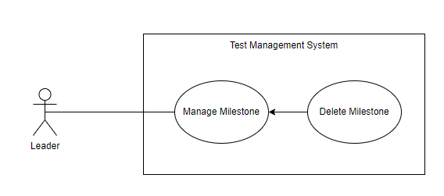

*Figure 23. <Use case>Delete Milestones*

#### 

| ID and Name: | **UC-23 Delete Milestones** | | |
| --- | --- | --- | --- |
| Created By: | Hoàng Lê Duy | Date Created: | 7/10/2022 |
| Primary Actor: | Leader | Secondary Actors: | TMS |
| Description: | This use case allows authorised users to delete milestones. | | |
| Trigger: | The actor sends a request to delete milestones in the project. | | |
| Preconditions: | PRE-1. Tester is logged into TMS. | | |
| Post-conditions: | POST-1. A milestone will be removed in project | | |
| Normal Flow: | **23.0. Delete Milestones**   1. **Leader** clicks the specific project. 2. **Leader** clicks the tab Milestones 3. **Leader** clicks the specific milestones. 4. **TMS** shows a delete popup with the Confirm message with two buttons for **Leader** can select: - “OK” button - “Cancel” button 5. a. **Leader** clicks on the “OK” button, **TMS** remove milestones   b. **Leader** clicks on the “Cancel” button, **TMS** closes and nothing changes. | | |
| Alternative Flows: | N/A | | |
| Exceptions: | **N/A** | | |
| Priority: | Medium | | |
| Frequency of Use: | Medium | | |
| Business Rules: | **BR-04**: The user must have logged in the Test Management System | | |
| Other Information: | N/A | | |
| Assumptions: | N/A | | |

#### 

#### 

### 2.9 Manage Test Plan

#### a. Get List Test Plan

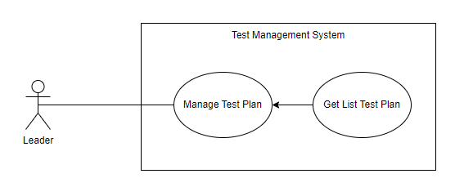

*Figure 24. <Use case>Get List Test Plan*

| UC ID and Name: | UC 24.Get Test Plan List | | |
| --- | --- | --- | --- |
| Created By: | Hoàng Lê Duy | Date Created: | 21/10/2022 |
| Primary Actor: | Leader | Secondary Actors: | TMS |
| Trigger: | The actor sends a request to get all test plan in the project. | | |
| Description: | This use case allows authorised users to view the test plan list available. | | |
| Preconditions: | **PRE-1**: The actor already logged into the TMS. | | |
| Post-conditions: | **POST-1**: The list of test case is returned to the actor who sends the request to view the test plan list | | |
| Normal Flow: | **24.0 Get Test Plan List**   1. **Leader** clicks the specific project. 2. **Leader** clicks the tab Test Plan 3. **Leader** send a request to get test plan list 4. **TMS** returns a list test plan. | | |
| Alternative Flows: | **N/A** | | |
| Exceptions: | **N/A** | | |
| Priority: | Medium | | |
| Frequency of Use: | Medium | | |
| Business Rules: | **BR-04**: The user must have logged in the Test Management System. | | |
| Other Information: | N/A | | |
| Assumptions: | N/A | | |

#### 

#### b. Add Test Plan

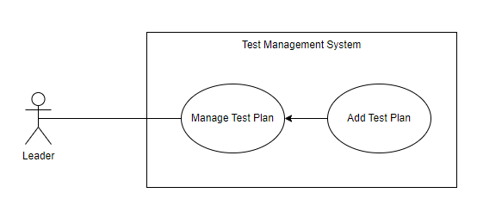

*Figure 25. <Use case>Add Test Plan*

#### 

| ID and Name: | **UC-25 Add a Test Plan** | | |
| --- | --- | --- | --- |
| Created By: | Hoàng Lê Duy | Date Created: | 7/10/2022 |
| Primary Actor: | Leader | Secondary Actors: | TMS |
| Description: | This use case allows authorised users to add a test plan. | | |
| Trigger: | The actor sends a request to add a test plan in the project. | | |
| Preconditions: | PRE-1. Leader is logged into TMS. | | |
| Post-conditions: | POST-1. A Test plan will be created in project | | |
| Normal Flow: | **25. Add Test Plan**   1. **Leader** clicks the specific project. 2. **Leader** clicks the tab Test Plan 3. **Leader** clicks the “Add Test Plan” button. 4. **TMS**  will pop up to add a test plan screen. 5. **TMS** required information from **Leader**: - Name: text input, blank, required - Milestones: dropdown list, select, required - Description: text input, blank, required - Test Run: button, required 6. **Leader** input to update project form:Name, Milestones, Description, Test Run. 7. **a. Tester** clicks the “Add Test Plan” button. **b. Tester** clicks the “Cancel” button, **TMS** returns to the dashboard page. 8. **a. TMS** will validate the Name, Milestones, Description, Test Run. ( See 25.0.E1, 25.0.E2). 9. **a. TMS** will store information details and add test plan. | | |
| Alternative Flows: | N/A | | |
| Exceptions: | **25.0 E1 The actor falls fill in all the text field**  - The TMS system returns to the actor to fill the missing field.  - The actor input fields again, returning to step 6 of normal flow.  **25.0 E2 The actor fills field not validate**  - The TMS required actor fills field again  - The actor refills the fields, returning to step 6 of normal flow. | | |
| Priority: | Medium | | |
| Frequency of Use: | Medium | | |
| Business Rules: | **BR-21:**  Default Test Plane include:   * Name * Milestones * Description * Test Run | | |
| Other Information: | N/A | | |
| Assumptions: | N/A | | |

#### 

#### c. Edit a Test Plan

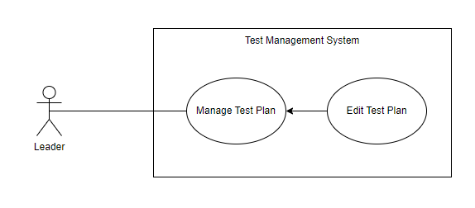

*Figure 26. <Use case>Edit Test Plan*

#### 

| ID and Name: | **UC-26 Edit Test Plan** | | |
| --- | --- | --- | --- |
| Created By: | Hoàng Lê Duy | Date Created: | 7/10/2022 |
| Primary Actor: | Leader | Secondary Actors: | TMS |
| Description: | This use case allows authorised users to edit a test plan. | | |
| Trigger: | The actor sends a request to edit a test plan in the project. | | |
| Preconditions: | PRE-1. Leader is logged into TMS. | | |
| Post-conditions: | POST-1. A Test plan will be edited in project | | |
| Normal Flow: | **26.0 Edit Test Plan**   1. **Leader** clicks the specific project. 2. **Leader** clicks the tab Test Plan 3. **Leader** clicks the specific Test Plan. 4. **TMS**  will pop up to add a test plan screen. 5. **TMS** required information from **Leader**: - Name: text input, blank, required - Milestones: dropdown list, select, required - Description: text input, blank, required - Test Run: button, required 6. **Leader** input to update project form:Name, Milestones, Description, Test Run. 7. **a. Leader** clicks the “Add Test Plan” button. **b. Leader** clicks the “Cancel” button, **TMS** returns to the dashboard page. 8. **a. TMS** will validate the Name, Milestones, Description, Test Run. ( See 25.0.E1, 25.0.E2). 9. **a. TMS** will store information details and edit test plan. | | |
| Alternative Flows: | N/A | | |
| Exceptions: | **26.0 E1 The actor falls fill in all the text field**  - The TMS system returns to the actor to fill the missing field.  - The actor input fields again, returning to step 6 of normal flow.  **26.0 E2 The actor fills field not validate**  - The TMS required actor fills field again  - The actor refills the fields, returning to step 6 of normal flow. | | |
| Priority: | Medium | | |
| Frequency of Use: | Medium | | |
| Business Rules: | **BR-21:**  Default Test Plane include:   * Name * Milestones * Description * Test Run | | |
| Other Information: | N/A | | |
| Assumptions: | N/A | | |

#### d. Delete Test Plan

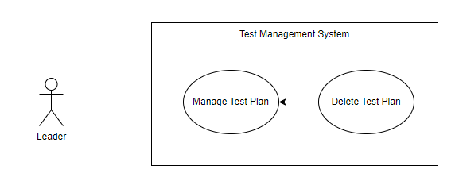

*Figure 27. <Use case>Delete Test Plan*

#### 

| ID and Name: | **UC-27 Delete Test Plan** | | |
| --- | --- | --- | --- |
| Created By: | Hoàng Lê Duy | Date Created: | 7/10/2022 |
| Primary Actor: | Leader | Secondary Actors: | TMS |
| Description: | This use case allows authorised users to delete a test plan. | | |
| Trigger: | The actor sends a request to delete a test plan in the project. | | |
| Preconditions: | PRE-1. Leader is logged into TMS. | | |
| Post-conditions: | POST-1. A Test plan will be deleted in project | | |
| Normal Flow: | **27.0 Delete Test Plan**   1. **Leader** clicks the specific project. 2. **Leader** clicks the tab Test Plan 3. **Leader** clicks the specific test plan. 4. **TMS** shows a delete popup with the Confirm message with two buttons for **Leader** can select: - “OK” button - “Cancel” button 5. a. **Leader** clicks on the “OK” button, **TMS** remove test plan   b. **Leader** clicks on the “Cancel” button, **TMS** closes and nothing changes. | | |
| Alternative Flows: | N/A | | |
| Exceptions: | **N/A** | | |
| Priority: | Medium | | |
| Frequency of Use: | Medium | | |
| Business Rules: | **BR-21:**  Default Test Plane include:   * Name * Milestones * Description * Test Run | | |
| Other Information: | N/A | | |
| Assumptions: | N/A | | |

### 2.10 Manage Test Run

#### a. Get List Test Run

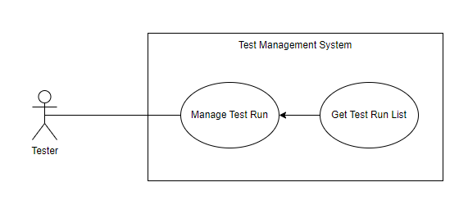

*Figure 28. <Use case>Get List Test Run*

| UC ID and Name: | UC 28.Get Test Run List | | |
| --- | --- | --- | --- |
| Created By: | Hoàng Lê Duy | Date Created: | 21/10/2022 |
| Primary Actor: | Tester | Secondary Actors: | TMS |
| Trigger: | The actor sends a request to get all test run in the project. | | |
| Description: | This use case allows authorised users to view the test run list available. | | |
| Preconditions: | **PRE-1**: The actor already logged into the TMS. | | |
| Post-conditions: | **POST-1**: The list of test case is returned to the actor who sends the request to view the test plan list | | |
| Normal Flow: | **28.0 Get Test Run List**   1. **Tester** clicks the specific project. 2. **Tester** clicks the tab Test Plan 3. **Tester** send a request to get test plan list 4. **TMS** returns a list test plan. | | |
| Alternative Flows: | **N/A** | | |
| Exceptions: | **N/A** | | |
| Priority: | Medium | | |
| Frequency of Use: | Medium | | |
| Business Rules: | **BR-04**: The user must have logged in the Test Management System. | | |
| Other Information: | N/A | | |
| Assumptions: | N/A | | |

#### 

#### b. Add Test Run

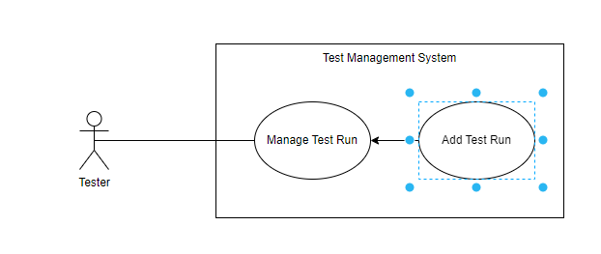

*Figure 29. <Use case>Add Test Run*

#### 

| ID and Name: | **UC-29 Add a Test Plan** | | |
| --- | --- | --- | --- |
| Created By: | Hoàng Lê Duy | Date Created: | 7/10/2022 |
| Primary Actor: | Tester | Secondary Actors: | TMS |
| Description: | This use case allows authorised users to add a test run. | | |
| Trigger: | The actor sends a request to add a test run in the project. | | |
| Preconditions: | PRE-1. Tester is logged into TMS. | | |
| Post-conditions: | POST-1. A Test Run will be created in project | | |
| Normal Flow: | **29. Add Test Run**   1. **Tester** clicks the specific project. 2. **Tester** clicks the tab Test Run 3. **Tester** clicks the “Add Test Run” button. 4. **TMS**  will pop up to add a test plan screen. 5. **TMS** required information from **Tester**: - Name: text input, blank, required - References: text input, blank, required - Milestones: dropdown list, select, required - Description: text input, blank, required - Assign to: drop down list, required 6. **Tester** input to update project form:Name, Milestones, Description, References, Assign To. 7. **a. Tester** clicks the “Add Test Run” button. **b. Tester** clicks the “Cancel” button, **TMS** returns to the dashboard page. 8. **a. TMS** will validate the Name, Milestones, Description, References, Assign To. ( See 29.0.E1, 29.0.E2). 9. **a. TMS** will store information details and add test run. | | |
| Alternative Flows: | N/A | | |
| Exceptions: | **29.0 E1 The actor falls fill in all the text field**  - The TMS system returns to the actor to fill the missing field.  - The actor input fields again, returning to step 6 of normal flow.  **29.0 E2 The actor fills field not validate**  - The TMS required actor fills field again  - The actor refills the fields, returning to step 6 of normal flow. | | |
| Priority: | Medium | | |
| Frequency of Use: | Medium | | |
| Business Rules: | **BR-22:**  Default Test Plane include:   * Name * Milestones * Description * Assign To * References | | |
| Other Information: | N/A | | |
| Assumptions: | N/A | | |

#### 

#### c. Edit a Test Run

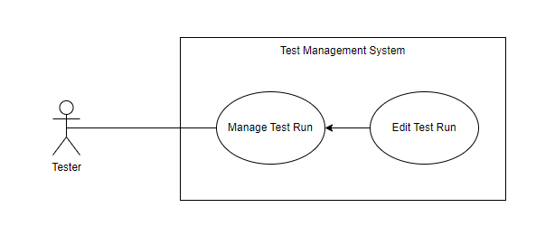

*Figure 30. <Use case>Edit Test Run*

#### 

#### 

| ID and Name: | **UC-30 Edit a Test Plan** | | |
| --- | --- | --- | --- |
| Created By: | Hoàng Lê Duy | Date Created: | 7/10/2022 |
| Primary Actor: | Tester | Secondary Actors: | TMS |
| Description: | This use case allows authorised users to edit a test run. | | |
| Trigger: | The actor sends a request to edit a test run in the project. | | |
| Preconditions: | PRE-1. Tester is logged into TMS. | | |
| Post-conditions: | POST-1. A Test Run will be edit in project | | |
| Normal Flow: | **30. Edit Test Run**   1. **Tester** clicks the specific project. 2. **Tester** clicks the tab Test Run 3. **Tester** clicks the specific project Test Run. 4. **TMS**  will pop up to Edit a test plan screen. 5. **TMS** required information from **Tester**: - Name: text input, blank, required - References: text input, blank, required - Milestones: dropdown list, select, required - Description: text input, blank, required - Assign to: drop down list, required 6. **Tester** input to update project form:Name, Milestones, Description, References, Assign To. 7. **a. Tester** clicks the “Add Test Run” button. **b. Tester** clicks the “Cancel” button, **TMS** returns to the dashboard page. 8. **a. TMS** will validate the Name, Milestones, Description, References, Assign To. ( See 29.0.E1, 29.0.E2). 9. **a. TMS** will store information details and edit test run. | | |
| Alternative Flows: | N/A | | |
| Exceptions: | **30.0 E1 The actor falls fill in all the text field**  - The TMS system returns to the actor to fill the missing field.  - The actor input fields again, returning to step 6 of normal flow.  **30.0 E2 The actor fills field not validate**  - The TMS required actor fills field again  - The actor refills the fields, returning to step 6 of normal flow. | | |
| Priority: | Medium | | |
| Frequency of Use: | Medium | | |
| Business Rules: | **BR-22:**  Default Test Plane include:   * Name * Milestones * Description * Assign To * References | | |
| Other Information: | N/A | | |
| Assumptions: | N/A | | |

#### 

#### d. Delete Test Run

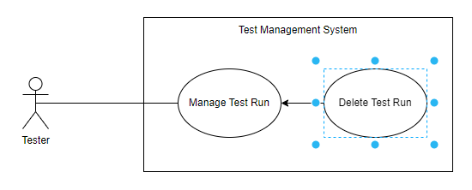

*Figure 31. <Use case>Delete Test Run*

#### 

| ID and Name: | **UC-31 Delete Test Run** | | |
| --- | --- | --- | --- |
| Created By: | Hoàng Lê Duy | Date Created: | 7/10/2022 |
| Primary Actor: | Tester | Secondary Actors: | TMS |
| Description: | This use case allows authorised users to delete a test plan. | | |
| Trigger: | The actor sends a request to delete a test run in the project. | | |
| Preconditions: | PRE-1. Tester is logged into TMS. | | |
| Post-conditions: | POST-1. A Test run will be deleted in project | | |
| Normal Flow: | **31.0 Delete Test Run**   1. **Tester** clicks the specific project. 2. **Tester** clicks the tab Test Run 3. **Tester** clicks the specific test Run. 4. **TMS** shows a delete popup with the Confirm message with two buttons for **Tester** can select: - “OK” button - “Cancel” button 5. a. **Tester** clicks on the “OK” button, **TMS** remove test run   b. **Tester** clicks on the “Cancel” button, **TMS** closes and nothing changes. | | |
| Alternative Flows: | N/A | | |
| Exceptions: | **N/A** | | |
| Priority: | Medium | | |
| Frequency of Use: | Medium | | |
| Business Rules: | **BR-21:**  Default Test Plane include:   * Name * Milestones * Description * Test Run | | |
| Other Information: | N/A | | |
| Assumptions: | N/A | | |

### 2.11 Manage Report

#### a. Add Report

### 

## 3. Functional Requirements

### 3.1 System Functional Overview

#### a. Screen Flow

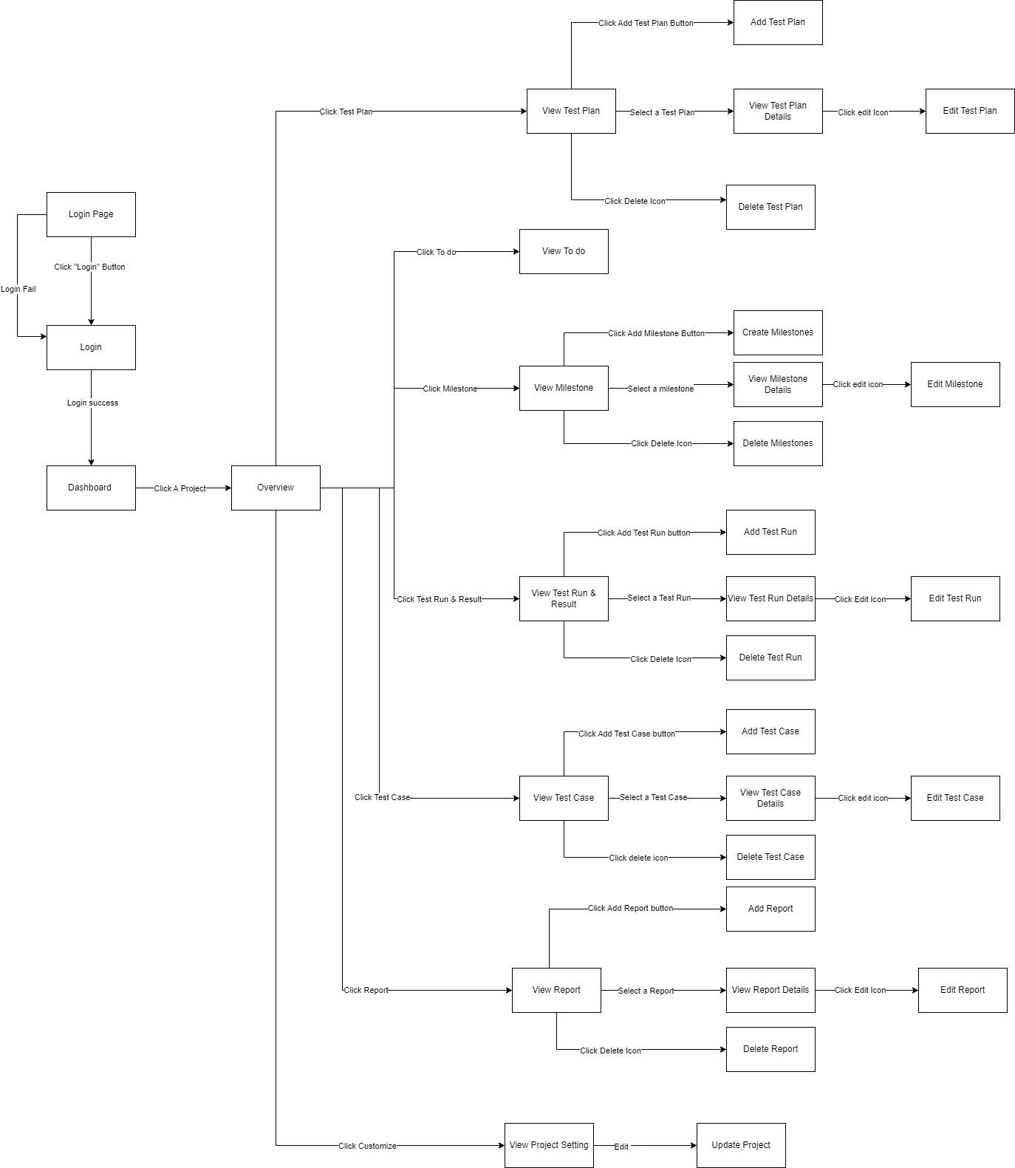

#### b. Screen Details

*[Provide the descriptions for the screens in the Screens Flow above]*

| **Id** | **Feature** | **Screen** | **Description** |
| --- | --- | --- | --- |
| 01 | Login | Login | Show form allows users to input email and password. |
| 02 | View Project List | Dashboard | Show all available project |
| 03 | View To do | To do | View user task |
| 04 | View Milestone list | Milestones | Show List available milestones |
| 05 | Add Milestone | Add Milestones | Show form allow user to add new milestones |
| 06 | Edit Milestones | Edit Milestones | Show form allow user to edit milestones |
| 07 | Delete Milestones | Milestones | Show button allow user to delete milestones |
| 08 | View Milestones Details | Milestones Details | Show milestones details |
| 09 | View Test Run List | Test Run | Show list available Test Run |
| 10 | View Test Run Details | Test Run Details | Show Test Run details |
| 11 | Add Test Run | Add Test Run | Show form allow user to add new test run |
| 12 | Edit Test Run | Edit Test Run | Show form allow user to edit test run |
| 13 | Delete Test Run | Delete Test Run | Show button allow user to delete test run |
| 14 | View Test Case List | Test Case | Show List Available Test Case |
| 15 | View Test Case Details | Test Case Details | Show Test Case Details |
| 16 | Add Test Case | Add Test Case | Show form allow user to add new test case |
| 17 | Edit Test Case | Edit Test Case | Show form allow user to edit test case |
| 18 | Delete Test Case | Test Case | Show button allow user to delete test case |
| 19 | View Test Plan List | Test Plan | Show list available Test Plan |
| 20 | View Test Plan Details | Test Plan Details | Show details of Test Plan |
| 21 | Add Test Plan | Add Test Plan | Show form allow user to add new test plan |
| 22 | Edit Test Plan | Edit Test Plan | Show form allow user to edit test plan |
| 23 | Delete Test Plan | Delete Test Plan | Show button allow user to delete test plan |
| 24 | View Report List | Report | Show list available report |
| 25 | View Report Details | Report Details | Show details of report |
| 26 | Add Report | Add Report | Show form allow user to add new report |
| 27 | Edit Report | Edit Report | Show form allow user to edit report |
| 28 | Delete Report | Delete Report | Show button allow user to delete report |
| 29 | View Project Setting | Project Setting | Show project setting |

#### c. Screen Authorization

| **Screen** | **Role1** | **Role2** | **Role3** | **Role4** |
| --- | --- | --- | --- | --- |
| Login | X | X | X | X |
| Milestone |  |  |  |  |
| View Milestone List | X | X | X | X |
| Add Milestone |  | X |  | X |
| Edit Milestone |  | X |  | X |
| Delete Milestone |  | X |  | X |
| View Milestone details | X | X | X | X |
| To do | X | X | X | X |
| Test Plan |  |  |  |  |
| View Test Plan List | X | X | X | X |
| Add Test Plan |  | X |  |  |
| Edit Test Plan |  | X |  |  |
| Delete Test Plan |  | X |  |  |
| View Test Plan Details | X | X | X | X |
| Test Run |  |  |  |  |
| View Test Run List | X | X | X | X |
| View Test Run Details | X | X | X | X |
| Add Test Run |  |  | X |  |
| Edit Test Run |  |  | X |  |
| Delete Test Run |  |  | X |  |
| Test Case |  |  |  |  |
| View Test Case List | X | X | X | X |
| View Test Case Details | X | X | X | X |
| Add Test Case |  |  | X |  |
| Edit Test Case |  |  | X |  |
| Delete Test Case |  |  | X |  |

In which:

* Role1: Administrator
* Role2: Leader
* Role 3: Tester
* Role 4: Viewer

#### d. Non-Screen Functions

*[Provide the descriptions for the non-screen system functions, i.e batch/cron job, service, API, etc.]*

| **#** | **System Function** | **Description** |
| --- | --- | --- |
| 1 |  |  |
| 2 | … |  |

#### e. Entity Relationship Diagram

*[Provide the entity relationship diagram and the entity descriptions in the table format as below]*

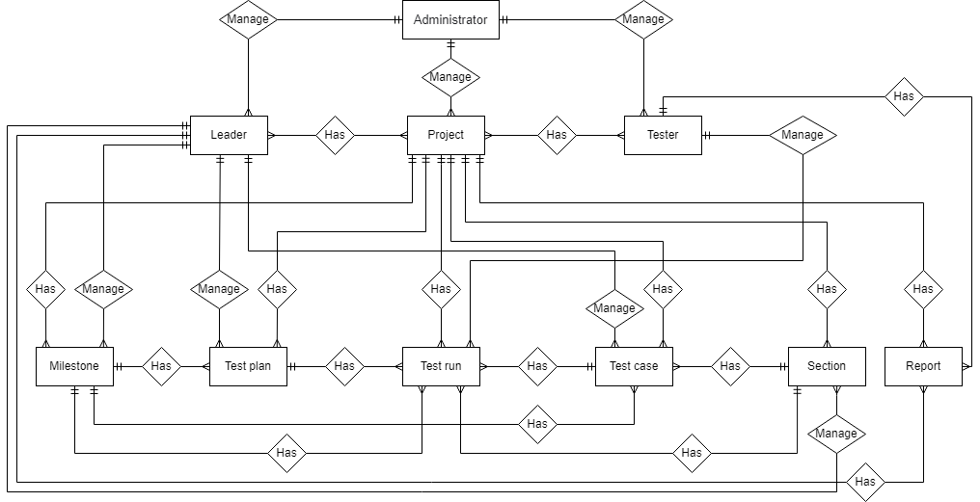

| **#** | **Entity** | **Description** |
| --- | --- | --- |
| 1 | User |  |
| 2 | Meal |  |
| 3 | Meal Subscription |  |
| 4 | … |  |

### 3.2 <<Feature Name 1>>

#### a. <<Function Name 1>>

*[A function can be a screen or a non-screen function (listed in the part 5.1 above). In this part, you need to provide the details on the related function, focus on mentioning below information*

* *Function trigger: how this function is triggered (navigation path, a timing frequency, etc.*
* *Function description: actors/roles, purpose, interface, data processing, etc.*
* *Screen layout: mockup prototype of the screen, sample below is for Manage Products screen*

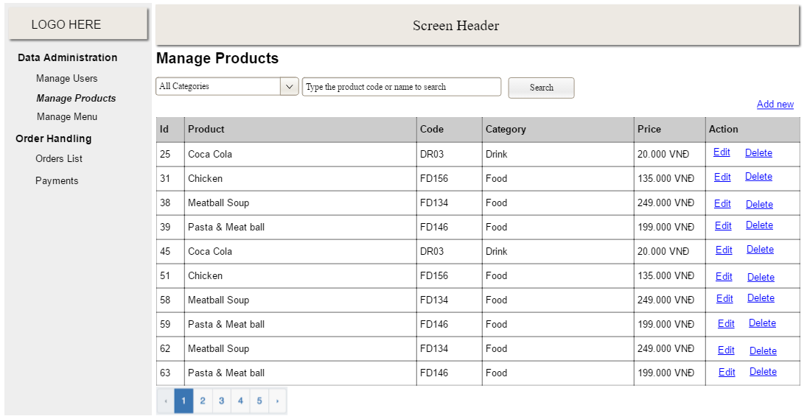

* *Function Details: provide explanation for the data, validation, functionalities (for both normal cases and abnormal cases), etc. of the function so that the reader can image how it work.*

*]*

#### b. <<Function Name 2>>

…

### 3.3 <<Feature Name 2>>

…

## 4. Non-Functional Requirements

### 4.1 External Interfaces

*[This section provides information to ensure that the system will communicate properly with users and with external hardware or software elements.]*

#### a. User Interfaces

*[Describe the logical characteristics of each interface between the software product and the users. This may include sample screen images, any GUI standards or product family style guides that are to be followed, screen layout constraints, standard buttons and functions (e.g., help) that will appear on every screen, keyboard shortcuts, error message display standards, and so on. Define the software components for which a user interface is needed. Details of the user interface design should be documented in a separate user interface specification.]*

UI-1: The Cafeteria Ordering System screen displays shall conform to the Process Impact Internet Application User Interface Standard, Version 2.0 [3].

UI-2: The system shall provide a help link from each displayed webpage to explain how to use that page.

UI-3: The webpages shall permit complete navigation and food item selection by using the keyboard alone, in addition to using mouse and keyboard combinations.

#### b. Software Interfaces

*[Describe the connections between this product and other software components (identified by name and version), including other applications, databases, operating systems, tools, libraries, websites, and integrated commercial components. State the purpose, formats, and contents of the messages, data, and control values exchanged between the software components. Specify the mappings of input and output data between the systems and any translations that need to be made for the data to get from one system to the other. Describe the services needed by or from external software components and the nature of the inte-component communications. Identify data that will be exchanged between or shared across software components. Specify non-functional requirements affecting the interface, such as service levels for responses times and frequencies, or security controls and restrictions.]*

SI-1: Cafeteria Inventory System

SI-1.1: The COS shall transmit the quantities of food items ordered to the Cafeteria Inventory System through a programmatic interface.

SI-1.2: The COS shall poll the Cafeteria Inventory System to determine whether a requested food item is available.

SI-1.3: When the Cafeteria Inventory System notifies the COS that a specific food item is no longer available, the COS shall remove that food item from the menu for the current date.

SI-2: Payroll System

The COS shall communicate with the Payroll System through a programmatic interface for the following operations:

SI-2.1: To allow a Patron to register and unregister for payroll deduction.

SI-2.2: To inquire whether a Patron is registered for payroll deduction.

SI-2.3: To inquire whether a Patron is eligible to register for payroll deduction.

SI-2.4: To submit a payment request for a purchased meal.

SI-2.5: To reverse all or part of a previous charge because a patron rejected a meal or wasn’t satisfied with it, or because the meal was not delivered per the confirmed delivery instructions.

#### c. Hardware Interfaces

*[Describe the characteristics of each interface between the software and hardware (if any) components of the system. This description might include the supported device types, the data and control interactions between the software and the hardware, and the communication protocols to be used. List the inputs and outputs, their formats, their valid values or ranges, and any timing issues developers need to be aware of. If this information is extensive, consider creating a separate interface specification document]*

No hardware interfaces have been identified.

#### d. Communications Interfaces

*[State the requirements for any communication functions the product will use, including e-mail, Web browser, network protocols, and electronic forms. Define any pertinent message formatting. Specify communication security or encryption issues, data transfer rates, handshaking, and synchronization mechanisms. State any constraints around these interfaces, such as whether e-mail attachments are acceptable or not.]*

CI-1: The COS shall send an email or text message (based on user account settings) to the Patron to confirm acceptance of an order, price, and delivery instructions.

CI-2: The COS shall send an email or text message (based on user account settings) to the Patron to report any problems with the meal order or delivery.

### 4.2 Quality Attributes

*[List all the required system characteristics (quality attributes) specification. Some of the possible attributes are provided with the guide/descriptions are mentioned here]*

#### a. Usability

* The texts, labels must be all in English.
* The content of the description can be written in Vietnamese

#### b. Reliability

* Exception rate is at minimum 1% over all working time

#### c. Performance

* Requests from web applications are responded in less than 5 seconds at 4 Mbps bandwidth speed and 1GHz processing speed of the CPU.

#### d. Dependability

##### d1. Security

*[Specify any requirements regarding security or privacy issues that restrict access to or use of the product. These could refer to physical, data, or software security. Security requirements often originate in business rules, so identify any security or privacy policies or regulations to which the product must conform. If these are documented in a business rules repository, just refer to them.]*

##### d2. Safety

*[Specify requirements that are concerned with possible loss, damage, or harm that could result from use of the product. Define any safeguards or actions that must be taken, as well as potentially dangerous actions that must be prevented. Identify any safety certifications, policies, or regulations to which the product must conform.]*

#### e. Supportability

*[This section indicates any requirements that will enhance the supportability or maintainability of the system being built, including coding standards, naming conventions, class libraries, maintenance access, and maintenance utilities.]*

#### f. Design Constraints

*[This section indicates any design constraints on the system being built. Design constraints represent design decisions that have been mandated and must be adhered to. Examples include software languages, software process requirements, prescribed use of developmental tools, architectural and design constraints, purchased components, class libraries, and so on.]*

#### g. Support Documents

*[Describes the requirements, if any, for o-line user documentation, help systems, help about notices, and so forth.]*

#### h. Purchased Components

*[This section describes any purchased components to be used with the system, any applicable licensing or usage restrictions, and any associated compatibility and interoperability or interface standards.]*

## 5. Other Requirements

*[Examples are: legal, regulatory or financial compliance, and standards requirements; requirements for product installation, configuration, startup, and shutdown; and logging, monitoring and audit trail requirements. Instead of just combining these all under "Other," add any new sections to the template that are pertinent to your project. Omit this section if all your requirements are accommodated in other sections. ]*

### 5.1 Appendix1 - Messages List

| **#** | **Message code** | **Message Type** | **Context** | **Content** |
| --- | --- | --- | --- | --- |
| 1 | MSG01 | In line | There is not any search result | *No search result.* |
| 2 | MSG02 | In red, under the text box | Input-required fields are empty | *The * field is required.* |
| 3 | MSG03 | Toast message | Updating asset(s) information successfully | *Update asset(s) successfully.* |
| 4 | MSG04 | Toast message | Adding new asset successfully | *Add asset successfully.* |
| 5 | MSG05 | Toast message | Confirming email of asset hand-over is sent successfully | *A confirmation email has been sent to {email_address}.* |
| 6 | MSG06 | Toast message | Resetting asset information successfully | *Return asset(s) successfully.* |
| 7 | MSG07 | Toast message | Deleting asset information successfully | *Delete asset(s) successfully.* |
| 8 | MSG08 | In red, under the text box | Input value length > max length | *Exceed max length of {max_length}.* |
| 9 | MSG09 | In line | Username or password is not correct when clicking sign-in | *Incorrect username or password. Please check again.* |

### 